**[MONACO REPORTER](http://monacoreporter.com/)**

FROM THE HEART OF THE PRINCIPALITY

[Kazuki Yamada new conductor of the Philharmonic Orchestra of Monte-Carlo](http://monacoreporter.com/2015/04/06/kazuki-yamada-new-conductor-of-the-philharmonic-orchestra-of-monte-carlo/)

[BY CELINA](http://monacoreporter.com/author/celinalafuentedelavotha/) [APRIL 6, 2015](http://monacoreporter.com/2015/04/06/kazuki-yamada-new-conductor-of-the-philharmonic-orchestra-of-monte-carlo/) [GIANLUIGI GELMETTI](http://monacoreporter.com/tag/gianluigi-gelmetti/) [KAZUKI YAMADA](http://monacoreporter.com/tag/kazuki-yamada/) [LES AMIS DE L'ORCHESTRA DE MONTE-CARLO](http://monacoreporter.com/tag/les-amis-de-lorchestra-de-monte-carlo/) [PHILHARMONIC ORCHESTRA OF MONTE-CARLO](http://monacoreporter.com/tag/philharmonic-orchestra-of-monte-carlo/)

**Gianluigi Gelmetti presented his successor**

Friday, April 2, 2015, at the Auditorium Rainier III, [Gianluigi Gelmetti](http://en.wikipedia.org/wiki/Gianluigi_Gelmetti) presented his successor Kazuki Yamada as Artistic and Musical Director of the [Philharmonic Orchestra of Monte-Carlo](http://www.opmc.mc/) (OPMC). HRH Princess of Hanovre, President of the Orchestra, had given Gelmetti the mission to find the best conductor to succeed him at the end of his mandate. The nomination that will take full effect in September 2016, will be preceded by a year during which Yamada will prepare the program for the season 2016/2017, while Gelmetti will receive the title of Honorary Director, continuing to assume the responsibility of the orchestra all along the season 2015/2016 that he prepared.

The announcement took place during a press conference in the presence of Paul Masseron, Interior Minister and Vice-President of the Administration Board of the Orchestra on his last day in this position before his retirement, Jean-Charles Curau, Director of Cultural Affairs, and members of the association of Friends of the OPMC presided by Smadar Eisenberg and other distinguished personalities. Guests were invited to a Cocktail with the opportunity to partake with the new conductor, who is known in the Principality through his many performances as guest conductor. Yamada said: *“When I came here to conduct the orchestra in 2011, I immediately felt a developing rapport between the musicians and me.”*

[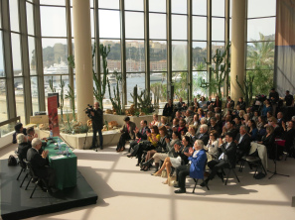](http://monacoreporter.com/2015/04/06/kazuki-yamada-new-conductor-of-the-philharmonic-orchestra-of-monte-carlo/an-ovation-from-the-audience-for-kazuki-yamada-celinalafuentedelavotha/%23main)

[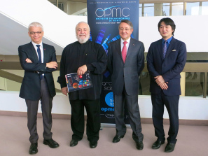](http://monacoreporter.com/2015/04/06/kazuki-yamada-new-conductor-of-the-philharmonic-orchestra-of-monte-carlo/jean-charles-curau-gianluigi-gelmetti-paul-masseron-and-kazuki-yamada-celinalafuentedelavotha/%23main)

[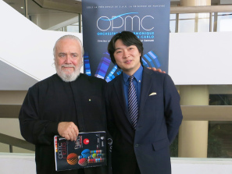](http://monacoreporter.com/2015/04/06/kazuki-yamada-new-conductor-of-the-philharmonic-orchestra-of-monte-carlo/gianluigi-gelmetti-and-kazuki-yamada-celinalafuentedelavotha/%23main)[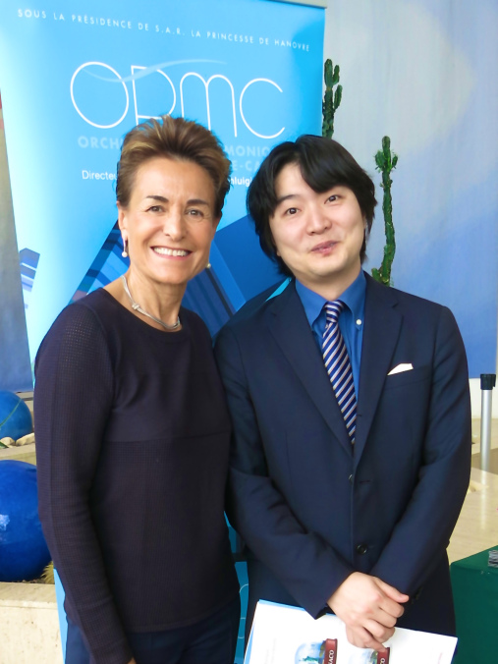](http://monacoreporter.com/2015/04/06/kazuki-yamada-new-conductor-of-the-philharmonic-orchestra-of-monte-carlo/celina-with-conductor-kazuki-yamada/%23main)

[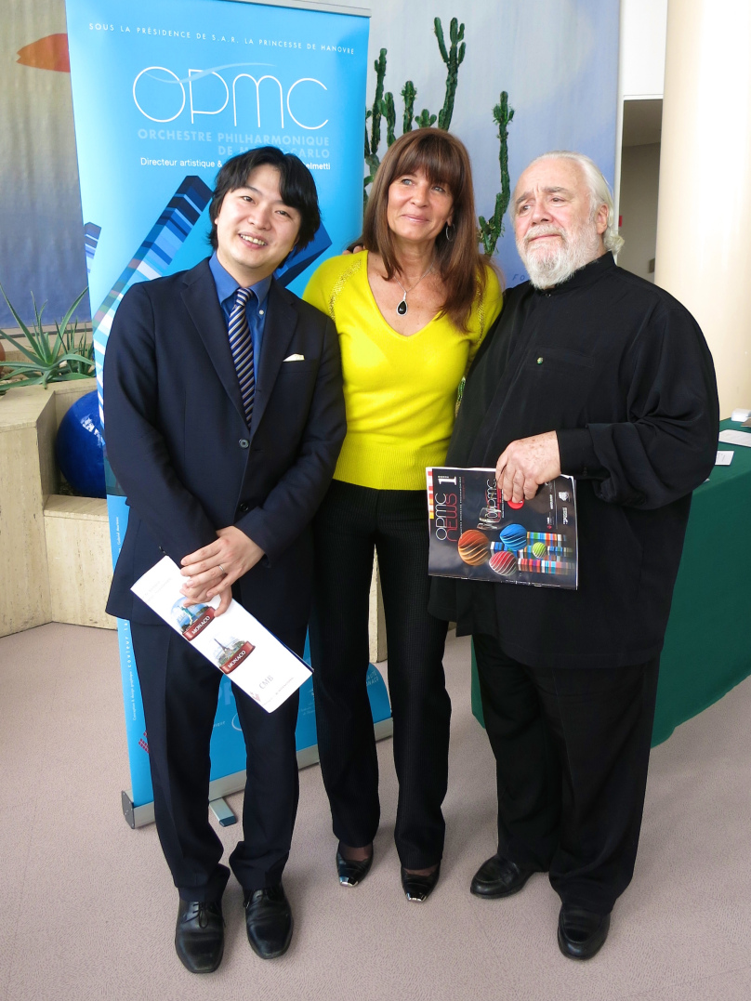](http://monacoreporter.com/2015/04/06/kazuki-yamada-new-conductor-of-the-philharmonic-orchestra-of-monte-carlo/kazuki-yamada-smadar-eisenberg-and-gianluigi-gelmetti-celinalafuentedelavotha/%23main)

**Kazuki Yamada conducting the Orchestra of Monte-Carlo into the future**

[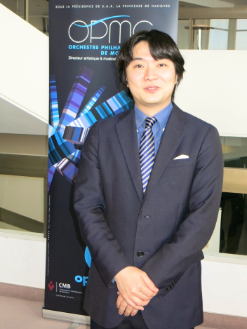](https://monacoreporter.files.wordpress.com/2015/04/conductor-yazuki-yamada-celinalafuentedelavotha.jpg)

Conductor Yazuki Yamada [@CelinaLafuenteDeLavotha](https://monacoreporter.wordpress.com/mentions/celinalafuentedelavotha/)

Yamada who since the Autumn of 2013 had been the OPMC’s principal guest conductor, appears regularly with the *Paris Orchestra*, *Philharmonia Orchestra*, *Dresden Philharmonic, Rundfunk Sinfonieiorchester Berlin*, *St Petersburg Philharmonic, Czech Philharmonic*, *City of Birmingham Symphony*, *Royal Stockholm Philharmonic*, *Gothenburg Symphony*, *Orchestre de Chambre de Laussane*, *Orquestra Sinfonica y Coro de RTVE* and *Tonkunster-Orchester at the Vienna Musikverein*.He is also Principal Guest Conductor of the *Orchestre de la Suisse Romande*. In Japan, he holds further titles of Principal Conductor of *Japan Philharmonic Orchestra*, Music Partner with Sedai Philharmonic and Ensemble Orchestral Kanzawa and Music Director of Yokoham Sinfonietta, an ensemble he founded when he was a student. A passionate of choral repertoire, he is Tokyo Philharmonic Chorus’s Residential Conductor, releasing four CDs with them.

Alongside his debut appearances with the *Helsinki Philharmonic*, *SWR Stuttgart*, *Orchestre National de Lyon* and his USA debut with the *Utah Symphony Orchestra*, he also carries out a large-scale project conducting Honegger’s *Jeanne d’Arc* with three orchestras: *Orchestre Philharmonique de Monte-Carlo*, *Orchestre National du Capitole de Toulouse* and *Orchestre de Paris* at the new Philharmonie hall in Paris. No other than French actress Marion Cotillard performs as Joan of Arc.

Yamada was born in Kanagawa Japan in 1979, and has been residing in Berlin, Germany. Graduated as Chief Conductor from the Tokyo National University of Fine Arts & Music, under the direction of Ken-ichiro Kobayashi and Yoko Matsuo, he received the Ataka-Prize in 2001. A year later he studied with Gerhard Markson at the International Summer Academy of Mozarteum Salzburg. He was the winner of the 51th Besancon International Competition for young conductors. In 2011 he received the Idemitsu Music Prize for young artists in Japan.Yamada is surely a breath of fresh air for the Orchestra in Monte-Carlo and will take them into the future.

Talented violinist Zhang Zhang, member of the OPMC, shared her thoughts about Yamada’s nomination*: “Since the passing of our much regretted chef* [*Yakov Kreizberg*](http://en.wikipedia.org/wiki/Yakov_Kreizberg://)*, we have been waiting to be united with a new director who would share his talent, time, artistic vision, as a dedicated leader as well as a trusted partner. Towards the greater development and advancement of our joint artistic future. The OPMC has a long history in the world of music and we look forward to pursuing an exciting future with Maître Yamada, continuing the glorious legacy of the Philharmonic, as one of the emblematic culture representatives of the Principality, at home and around the world, for years to come.”*

***“The principal task of a conductor is not to put himself in evidence but to disappear behind his functions as much as possible. We are pilots, not servants.” Franz Liszt***